文件编号：LTE_HeNB_PDCP_DYCS_V1.0

TD-LTE HeNB协议栈软件系统

PDCP子系统
单元测试报告

拟制：贾宝雷
时间：2011/3/3

中国科学院计算技术研究所
无线通信技术研究中心
软件组
LTE协议栈项目组
修改记录
文件编号 | 版本号 | 拟制人/  修改人 | 拟制/修改日期 | 更改理由 | 主要更改内容  （写要点即可）
 | V0.5 | 贾宝雷 | 2011/3/3
注1：每次更改归档文件（指归档到组内及研究室的文件）时，需填写此表。
注2：文件第一次归档时，“更改理由”、“主要更改内容”栏写“无”。
修改列表：


本文档的程序或内容受版权法的保护，未经中科院计算所的书面许可，不得擅自泄漏、拷贝或复制本文档资料的全部或部分。

1 引言 1
1.1 背景 1
1.2 定义 1
1.3 参考资料 1
2 测试模块 2
2.1 模块名 2
2.2 文件名 2
2.3 测试人 2
3 函数测试 1
3.1 void* create_pdcp_entity(RbType rb_type, RlcTransMode rlc_mode, PdcpConfig *pdcp_config_p) 1
3.1.1 函数描述： 1
3.1.2 测试用例： 2
3.2 被测函数：INT32 delete_pdcp_entity(Rnti ue_rnti, UINT8 rb_id) 4
3.2.1 函数描述： 4
3.2.2测试用例 5
3.3 被测函数：INT32 send_drb(Rnti ue_rnti, UINT8 rb_id, UINT8 *msg_p, UINT32 len) 6
3.3.1 函数描述： 6
3.3.2测试用例 8
3.4 被测函数：INT32 send_srb(Rnti ue_rnti, UINT8 rb_id, UINT8 *msg_p, UINT32 len) 13
3.4.1 函数描述： 13
3.4.2测试用例 14
3.5 被测函数：INT32 pdcp_send(Rnti ue_rnti, UINT8 rb_id, UINT8 *msg_p, UINT32 len) 17
3.5.1 函数描述： 17
3.5.2测试用例 18
3.6 被测函数：INT32 receive_srb(Rnti ue_rnti, UINT8 rb_id, UINT8 *msg_p, UINT32 len) 23
3.6.1 函数描述： 23
3.6.2测试用例 24
3.7 被测函数：INT32 process_status_report (Rnti ue_rnti，UINT8 rb_id ,UINT32 fms_count，UINT8 *bitmap_p, UINT32 bitmap_len) 27
3.7.1 函数描述： 27
3.7.2测试用例 28
3.8 被测函数：INT32 receive_drb(Rnti ue_rnti, UINT8 rb_id, UINT8 *msg_p, UINT32 msg_len) 32
3.8.1 函数描述： 32
3.8.2测试用例 35
3.9 被测函数：UINT8 create_status_report (UINT32 ls_count，RxPdcpSduList *rx_list_p，UINT32 *pdu_len) 48
3.9.1 函数描述： 48
3.9.2测试用例 49
3.10 被测函数：INT32 reestablish_pdcp (Rnti ue_rnti,UINT8 rb_id,PdcpConfig pdcp_config_p) 51
3.10.1 函数描述： 51
3.10.2测试用例 52
3.11 被测函数：INT32 ack4pdcp_sdu (Rnti ue_rnti, UINT8 rb_id, UINT32 count) 60
3.11.1 函数描述： 60
3.11.2测试用例 60
5 其他测试 1
6 附录1 测试类型 1
1. 等价类划分 1
2. 边值分析法 2
3. 语句覆盖 3
4. 判定覆盖 3
5. 条件覆盖 4
6. 判定／条件覆盖 4
7. 条件组合覆盖 5

单元测试报告

1 引言

1.1 背景
- 软件系统：TD-LTE HeNB协议栈软件系统
- 开发环境：
  - 开发工具：Vim
  - 编程语言：C语言
  - 支持库：GLIBC
  - 编译器：GCC
  - 调试器：GDB
- 操作系统：
Linux-Release-2.6.20
- 测试环境：
  - 运行平台： PC-Linux
  - CPU类型： P4-1.6G
  - 内存大小：2046M，2M

1.2 定义
列出本文件中用到的专门术语的定义和外文首字母组词的原词组。
如：
- SDU：Service Data Unit；
- PDU：Protocal Data Unit.

1.3 参考资料
列出有关的参考文件，包括属于本项目的其他已发表文件和本文件中各处引用的文件、资料，包括所用到的软件开发标准。如：
- 《3GPP TS 36.323: "Evolved Universal Terrestrial Radio Access (E-UTRA); Packet Data Convergence Protocol (PDCP) Specification".》；
- 《HeNB端-PDCP子系统详细设计说明书》；

2 测试模块

2.1 模块名
分组数据汇聚模块（PDCP）。

2.2 文件名
被测文件名：pdcp.c pdcp.h。

2.3 测试人
测试人：贾宝雷
邮箱：jiabaolei@ict.ac.cn。

3 函数测试
被测函数 | 函数说明
create_pdcp_entity | 根据配置参数和要求，创建一个PDCP实体
delete_pdcp_entity | 删除指定的PDCP实体
send_drb | 数据面数据发送函数，其中包括AM数据和UM数据
send_srb | 控制面数据发送函数，即SRB数据
pdcp_send | PDCP的发送函数，控制面和用户面都通过此接口发送数据
receive_srb | PDCP SRB接收函数，SRB数据均为AM模式
process_status_report | 根据对端传过来的状态报告，对本端缓存中的已经被对端确认收到的SDU进行删除，并通知下层取消此PDU的发送
receive_drb | PDCP DRB接收函数。 处理PDCP PDU，PDU分为两类，控制PDU和数据PDU
create_status_report | 在PDCP重建立时，如果对应RB需要发送状态报告，则使用此函数，根据接收缓存链表创建状态报告
reestablish_pdcp | 根据配置参数和要求，重建立一个PDCP实体
ack4pdcp_sdu | 在RLC收到接收端确认后，指示PDCP删除指定COUNT值的缓存SDU

3.1 被测函数：void* create_pdcp_entity(RbType rb_type, RlcTransMode rlc_mode, PdcpConfig *pdcp_config_p)

3.1.1 函数描述：
功能描述
根据配置参数和要求，创建一个PDCP实体。
输入
rb_type：要创建的PDCP实体的类型，SRB或者DRB。
rlc_mode：PDCP实体对应的DRB为AM模式还是UM模式，在创建SRB实体时，此参数无效
pdcp_config_p：PDCP实体的参数
算法与处理流程
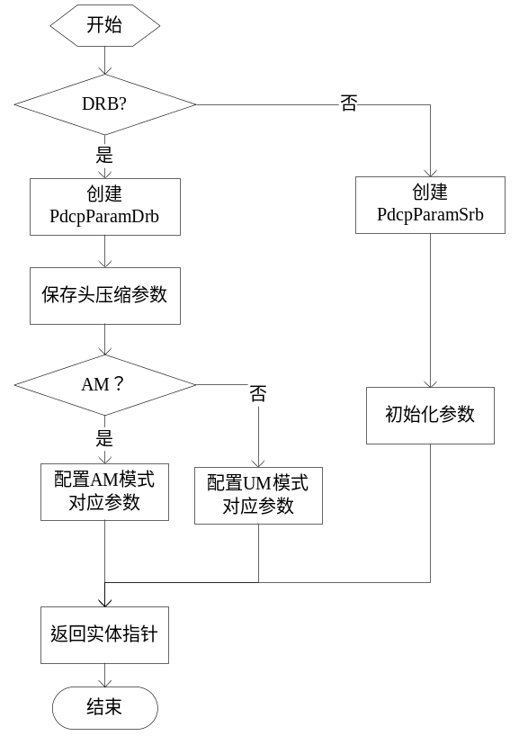
输出
无。
返回
PDCP实体指针：成功。
NULL：失败

3.1.2 测试用例：

测试用例：eNB_PDCP_0001
说明 | 当需要创建SRB实体时，函数是否能按照配置正确创建SRB对应的PDCP实体
输入 | rb_type = SRB  rlc_mode = UM_MODE（无效）  pdcp_config_p 无效
预期输出 | 输出非空PDCP实体指针  dl_count = 0  ul_count = 0

测试修改
无。
测试方法
根据测试目的构建PDCP参数，调用被测函数，将创建出的PDCP实体保存，并打印其中参数信息来验证函数功能。
测试输出
SRB entity created
ul_count:0
dl_count:0
malloc() used 4, free() used 4
All the memory that has been assigned has been released!
There is no mem which has been freed 2 times。
BUG描述
序号 | BUG描述 | 修改情况 | 其他说明

测试用例：eNB_PDCP_0002
说明 | 当需要创建DRB实体时，函数是否能按照配置正确创建DRB对应的PDCP实体。
输入 | rb_type = DRB  rlc_mode = UM_MODE  sn_size = SN_SIZE_12
预期输出 | 非空PDCP实体指针  dl_count = 0  ul_count = 0  sn_size = 1（12位）

测试方法
测试原理及方法描述，包括测试期望输出。必须说明通过何种方式，可以对测试过程进行重现。要求在不修改测试代码的情况下完成对测试用例的重现。
测试输出
DRB entity created
ul_count:0
dl_count:0
max_cid:12
sn size:1
status report ind:0
malloc() used 8, free() used 8
All the memory that has been assigned has been released!
There is no mem which has been freed 2 times。
BUG描述
序号 | BUG描述 | 修改情况 | 其他说明

3.2 被测函数：INT32 delete_pdcp_entity(Rnti ue_rnti, UINT8 rb_id)

3.2.1 函数描述：
功能描述
删除指定的PDCP实体。
输入
ue_rnti：用来区分不同UE的标志号。
rb_id：用来区分不同RB的标识号。
算法与处理流程
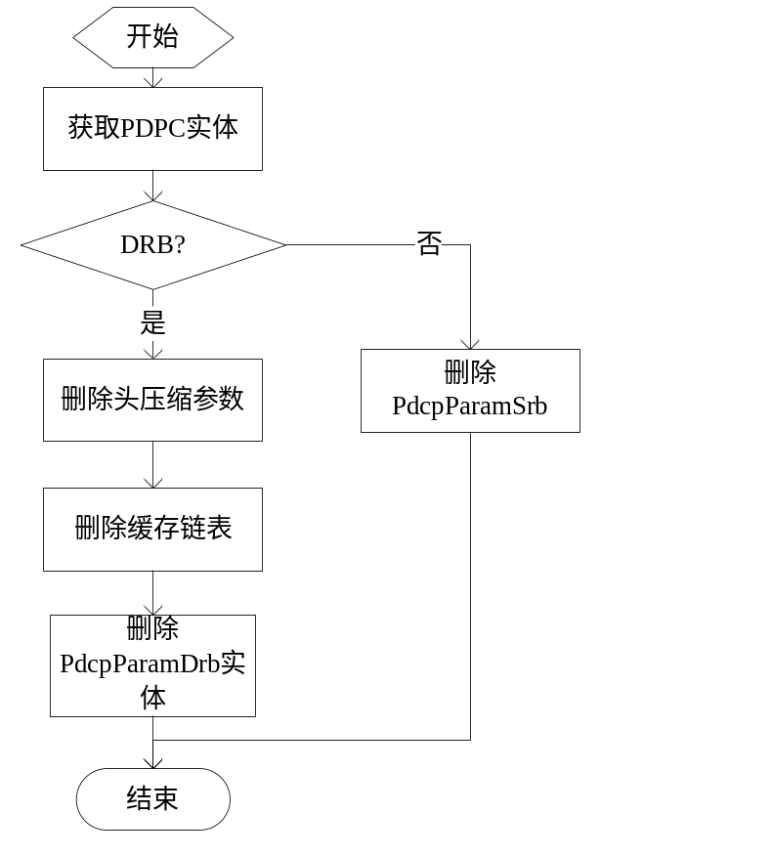
输出
无。
返回
0：成功。
-1：失败

3.2.2测试用例

测试用例：eNB_PDCP_0003

说明 | 当删除的PDCP实体为SRB类型时，测试函数能否正确删除此PDCP实体。。
输入 | ue_rnti=1 rb_id = 1。对应的PCDP实体为SRB类型
预期输出 | 删除成功，内存无泄漏

测试方法
首先在测试环境创建相应的PDCP实体，然后调用被测函数，删除对应实体。
测试输出
SRB entity created
delete pdcp entity success!
malloc() used 7, free() used 7
All the memory that has been assigned has been released!
There is no mem which has been freed 2 times

测试用例：eNB_PDCP_0004

说明 | 当删除的PDCP实体为DRB类型时，测试函数是否能正确删除此PDCP实体。
输入 | ue_rnti=1 rb_id=1 对应的PDCP实体类型为DRB类型，头压缩参数不为空，接收缓存链表不为空，发送缓存链表不为空
预期输出 | PDCP实体删除成功，内存无泄漏

测试方法
首先在测试环境创建相应的PDCP实体，然后调用被测函数，删除对应实体。
测试输出
DRB entity created
delete pdcp entity success!
malloc() used 7, free() used 7
All the memory that has been assigned has been released!
There is no mem which has been freed 2 times

3.3 被测函数：INT32 send_drb(Rnti ue_rnti, UINT8 rb_id, UINT8 *msg_p, UINT32 len)

3.3.1 函数描述：
功能描述
数据面数据发送函数，其中包括AM数据和UM数据，在发送到下层之前，先要缓存，对于AM，需要缓存SDU，对于UM 不需要缓存SDU。
输入
ue_id：用来区分不同UE的标志号，以标志此数据发往哪个UE。
rb_id：用来区分不同RB的标识号，以标志此数据属于哪个无线承载
msg_p：数据指针。
len：数据长度，字节为单位。
算法与处理流程
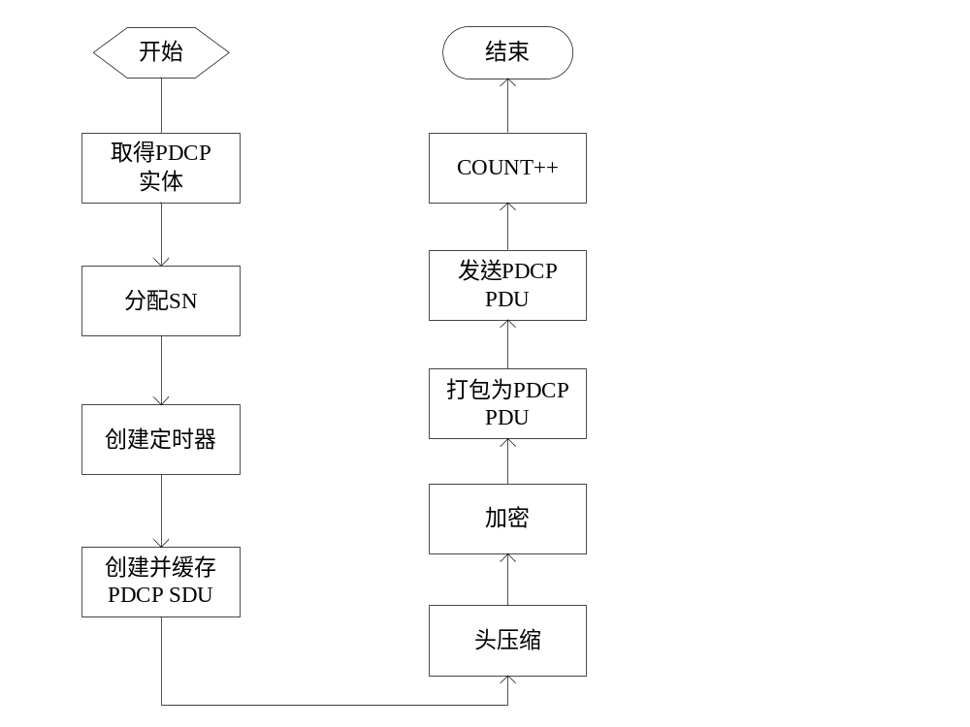
输出
无。
返回
0：成功。
-1：失败

3.3.2测试用例

测试用例：eNB_PDCP_0005

说明 | 测试DRB发送流程是否正确。
输入 | sn_size = 12 RlcTransMode = UM_MODE，SN从0开始，Data部分为连续整数
预期输出 | 不缓存SDU 只缓存count值和discard timer。PDU格式为：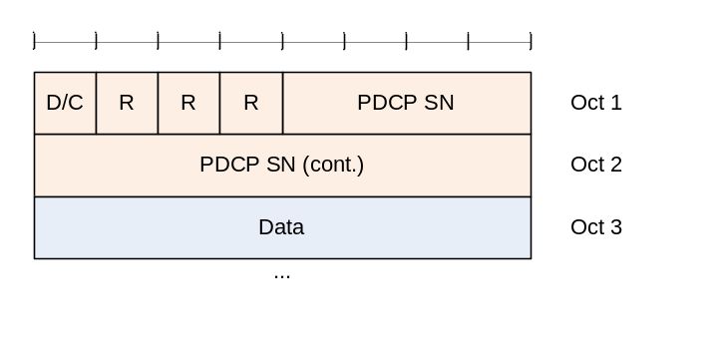  在UM模式时，SDU缓存不在PDCP层存储

测试方法
在测试环境中创建PDCP实体，使被测函数取得此PDCP实体，按照需求配置PDCP实体后，然后构造PDCP SDU，调用发送函数，达到测试目的
测试输出
DRB entity created
RLC received PDU count:0
The memory "PDCP PDU:" len is: 12
80 0 0 1 2 3 4 5 6 7 8 9
RLC received PDU count:1
The memory "PDCP PDU:" len is: 12
80 1 1 2 3 4 5 6 7 8 9 a
RLC received PDU count:2
The memory "PDCP PDU:" len is: 12
80 2 2 3 4 5 6 7 8 9 a b
RLC received PDU count:3
The memory "PDCP PDU:" len is: 12
80 3 3 4 5 6 7 8 9 a b c
RLC received PDU count:4
The memory "PDCP PDU:" len is: 12
80 4 4 5 6 7 8 9 a b c d
RLC received PDU count:5
The memory "PDCP PDU:" len is: 12
80 5 5 6 7 8 9 a b c d e
RLC received PDU count:6
The memory "PDCP PDU:" len is: 12
80 6 6 7 8 9 a b c d e f
RLC received PDU count:7
The memory "PDCP PDU:" len is: 12
80 7 7 8 9 a b c d e f 10
RLC received PDU count:8
The memory "PDCP PDU:" len is: 12
80 8 8 9 a b c d e f 10 11
RLC received PDU count:9
The memory "PDCP PDU:" len is: 12
80 9 9 a b c d e f 10 11 12
sdu in sdu buffer:
count:0
no sdu buffer
count:1
no sdu buffer
count:2
no sdu buffer
count:3
no sdu buffer
count:4
no sdu buffer
count:5
no sdu buffer
count:6
no sdu buffer
count:7
no sdu buffer
count:8
no sdu buffer
count:9
no sdu buffer
malloc() used 56, free() used 56
All the memory that has been assigned has been released!
There is no mem which has been freed 2 times

测试用例：eNB_PDCP_0006

说明 | 测试DRB发送流程是否正确。
输入 | sn_size = 7 RlcTransMode = UM_MODE
预期输出 | 不缓存SDU 只缓存count值和discard timer。PDU格式为：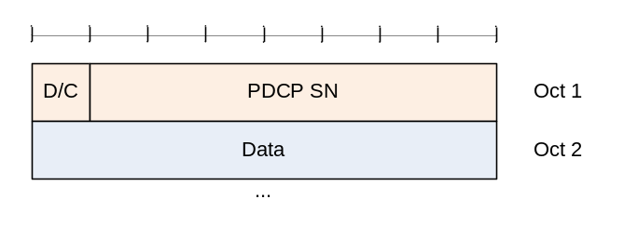

测试方法
在测试环境中创建PDCP实体，使被测函数取得此PDCP实体，按照需求配置PDCP实体后，然后构造PDCP SDU，调用发送函数，达到测试目的。
测试输出
DRB entity created
RLC received PDU count:0
The memory "PDCP PDU:" len is: 11
80 0 1 2 3 4 5 6 7 8 9
RLC received PDU count:1
The memory "PDCP PDU:" len is: 11
81 1 2 3 4 5 6 7 8 9 a
RLC received PDU count:2
The memory "PDCP PDU:" len is: 11
82 2 3 4 5 6 7 8 9 a b
RLC received PDU count:3
The memory "PDCP PDU:" len is: 11
83 3 4 5 6 7 8 9 a b c
RLC received PDU count:4
The memory "PDCP PDU:" len is: 11
84 4 5 6 7 8 9 a b c d
RLC received PDU count:5
The memory "PDCP PDU:" len is: 11
85 5 6 7 8 9 a b c d e
RLC received PDU count:6
The memory "PDCP PDU:" len is: 11
86 6 7 8 9 a b c d e f
RLC received PDU count:7
The memory "PDCP PDU:" len is: 11
87 7 8 9 a b c d e f 10
RLC received PDU count:8
The memory "PDCP PDU:" len is: 11
88 8 9 a b c d e f 10 11
RLC received PDU count:9
The memory "PDCP PDU:" len is: 11
89 9 a b c d e f 10 11 12
sdu in sdu buffer:
count:0
no sdu buffer
count:1
no sdu buffer
count:2
no sdu buffer
count:3
no sdu buffer
count:4
no sdu buffer
count:5
no sdu buffer
count:6
no sdu buffer
count:7
no sdu buffer
count:8
no sdu buffer
count:9
no sdu buffer
malloc() used 56, free() used 56
All the memory that has been assigned has been released!
There is no mem which has been freed 2 times

测试用例：eNB_PDCP_0007

说明 | 测试DRB发送流程是否正确。
输入 | RlcTransMode = AM_MODE
预期输出 | 缓存SDU count值 discard timer PDU格式：

测试方法
在测试环境中创建PDCP实体，使被测函数取得此PDCP实体，按照需求配置PDCP实体后，然后构造PDCP SDU，调用发送函数，达到测试目的。
测试输出
DRB entity created
RLC received PDU count:0
The memory "PDCP PDU:" len is: 12
80 0 0 1 2 3 4 5 6 7 8 9
RLC received PDU count:1
The memory "PDCP PDU:" len is: 12
80 1 1 2 3 4 5 6 7 8 9 a
RLC received PDU count:2
The memory "PDCP PDU:" len is: 12
80 2 2 3 4 5 6 7 8 9 a b
RLC received PDU count:3
The memory "PDCP PDU:" len is: 12
80 3 3 4 5 6 7 8 9 a b c
RLC received PDU count:4
The memory "PDCP PDU:" len is: 12
80 4 4 5 6 7 8 9 a b c d
RLC received PDU count:5
The memory "PDCP PDU:" len is: 12
80 5 5 6 7 8 9 a b c d e
RLC received PDU count:6
The memory "PDCP PDU:" len is: 12
80 6 6 7 8 9 a b c d e f
RLC received PDU count:7
The memory "PDCP PDU:" len is: 12
80 7 7 8 9 a b c d e f 10
RLC received PDU count:8
The memory "PDCP PDU:" len is: 12
80 8 8 9 a b c d e f 10 11
RLC received PDU count:9
The memory "PDCP PDU:" len is: 12
80 9 9 a b c d e f 10 11 12
sdu in sdu buffer:
count:0
The memory "sdu:" len is: 10
0 1 2 3 4 5 6 7 8 9
count:1
The memory "sdu:" len is: 10
1 2 3 4 5 6 7 8 9 a
count:2
The memory "sdu:" len is: 10
2 3 4 5 6 7 8 9 a b
count:3
The memory "sdu:" len is: 10
3 4 5 6 7 8 9 a b c
count:4
The memory "sdu:" len is: 10
4 5 6 7 8 9 a b c d
count:5
The memory "sdu:" len is: 10
5 6 7 8 9 a b c d e
count:6
The memory "sdu:" len is: 10
6 7 8 9 a b c d e f
count:7
The memory "sdu:" len is: 10
7 8 9 a b c d e f 10
count:8
The memory "sdu:" len is: 10
8 9 a b c d e f 10 11
count:9
The memory "sdu:" len is: 10
9 a b c d e f 10 11 12
malloc() used 66, free() used 66
All the memory that has been assigned has been released!
There is no mem which has been freed 2 times

3.4 被测函数：INT32 send_srb(Rnti ue_rnti, UINT8 rb_id, UINT8 *msg_p, UINT32 len)

3.4.1 函数描述：
功能描述
控制面数据发送函数，即SRB数据。
输入
ue_id：用来区分不同UE的标志号，以标志此数据发往哪个UE。
rb_id：用来区分不同RB的标识号，以标志此数据属于哪个无线承载
msg_p：数据指针。
len：数据长度，字节为单位。
算法与处理流程
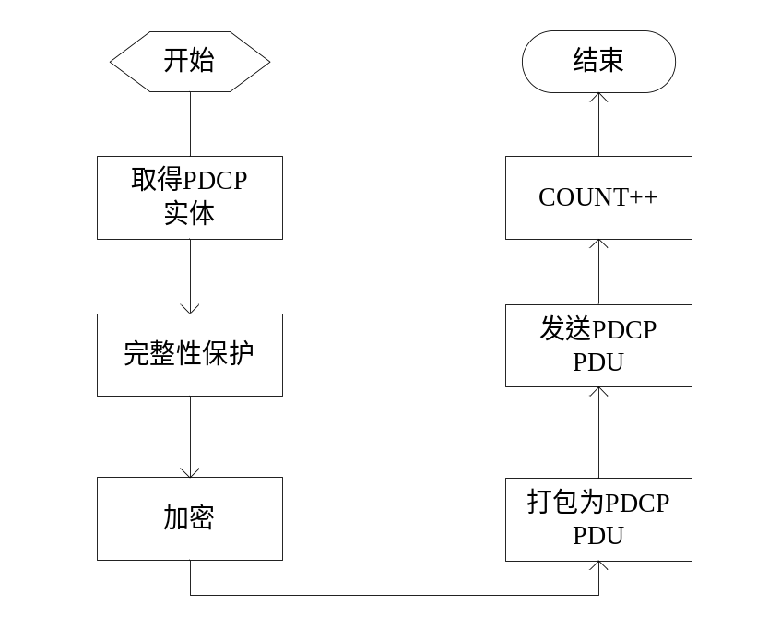
输出
无。
返回
0：成功。
-1：失败

3.4.2测试用例

测试用例：eNB_PDCP_0008

说明 | 测试发送流程是否正确，打包是否正确。
输入 | msg_p为长10字节的内存块，内容为递增值，完整性保护关闭
预期输出 | PDU格式：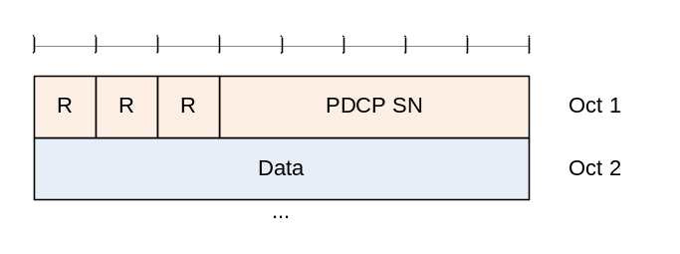其中SN域递增1

测试方法
在测试环境中创建PDCP实体，使被测函数取得此PDCP实体，按照需求配置PDCP实体后，然后构造PDCP SDU，调用发送函数，达到测试目的
测试输出
SRB entity created
RLC received PDU count:0
The memory "PDCP PDU:" len is: 11
0 0 1 2 3 4 5 6 7 8 9
RLC received PDU count:1
The memory "PDCP PDU:" len is: 11
1 1 2 3 4 5 6 7 8 9 a
RLC received PDU count:2
The memory "PDCP PDU:" len is: 11
2 2 3 4 5 6 7 8 9 a b
RLC received PDU count:3
The memory "PDCP PDU:" len is: 11
3 3 4 5 6 7 8 9 a b c
RLC received PDU count:4
The memory "PDCP PDU:" len is: 11
4 4 5 6 7 8 9 a b c d
RLC received PDU count:5
The memory "PDCP PDU:" len is: 11
5 5 6 7 8 9 a b c d e
RLC received PDU count:6
The memory "PDCP PDU:" len is: 11
6 6 7 8 9 a b c d e f
RLC received PDU count:7
The memory "PDCP PDU:" len is: 11
7 7 8 9 a b c d e f 10
RLC received PDU count:8
The memory "PDCP PDU:" len is: 11
8 8 9 a b c d e f 10 11
RLC received PDU count:9
The memory "PDCP PDU:" len is: 11
9 9 a b c d e f 10 11 12
delete pdcp entity success!
malloc() used 41, free() used 41
All the memory that has been assigned has been released!
There is no mem which has been freed 2 times

测试用例：eNB_PDCP_0009

说明 | 测试发送流程是否正确，打包是否正确
输入 | msg_p为长10字节的内存块，内容为递增值，完整性保护打开
预期输出 | PDU格式：  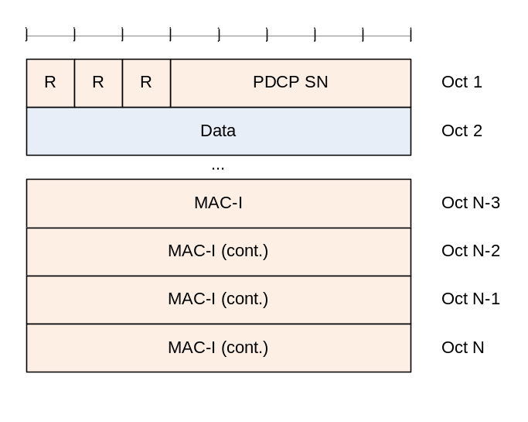

测试方法
在测试环境中创建PDCP实体，使被测函数取得此PDCP实体，按照需求配置PDCP实体后，然后构造PDCP SDU，调用发送函数，达到测试目的。
测试输出
SRB entity created
RLC received PDU count:0
The memory "PDCP PDU:" len is: 15
0 0 1 2 3 4 5 6 7 8 9 17 39 6d c8
RLC received PDU count:1
The memory "PDCP PDU:" len is: 15
1 1 2 3 4 5 6 7 8 9 a df 56 1e 81
RLC received PDU count:2
The memory "PDCP PDU:" len is: 15
2 2 3 4 5 6 7 8 9 a b 7c eb 44 f8
RLC received PDU count:3
The memory "PDCP PDU:" len is: 15
3 3 4 5 6 7 8 9 a b c 94 ec fd 33
RLC received PDU count:4
The memory "PDCP PDU:" len is: 15
4 4 5 6 7 8 9 a b c d 78 8a 45 13
RLC received PDU count:5
The memory "PDCP PDU:" len is: 15
5 5 6 7 8 9 a b c d e d dc bc fd
RLC received PDU count:6
The memory "PDCP PDU:" len is: 15
6 6 7 8 9 a b c d e f 89 2b 96 b6
RLC received PDU count:7
The memory "PDCP PDU:" len is: 15
7 7 8 9 a b c d e f 10 6c 8c 31 1c
RLC received PDU count:8
The memory "PDCP PDU:" len is: 15
8 8 9 a b c d e f 10 11 94 47 ed 84
RLC received PDU count:9
The memory "PDCP PDU:" len is: 15
9 9 a b c d e f 10 11 12 73 74 8c 80
delete pdcp entity success!
malloc() used 81, free() used 81
All the memory that has been assigned has been released!
There is no mem which has been freed 2 times

3.5 被测函数：INT32 pdcp_send(Rnti ue_rnti, UINT8 rb_id, UINT8 *msg_p, UINT32 len)

3.5.1 函数描述：
功能描述
PDCP的发送函数，控制面和用户面都通过此接口发送数据。
输入
ue_id：用来区分不同UE的标志号，以标志此数据发往哪个UE。
rb_id：用来区分不同RB的标识号，以标志此数据属于哪个无线承载
msg_p：数据指针，由调用者分配，本层释放。
len：数据长度，字节为单位。
算法与处理流程
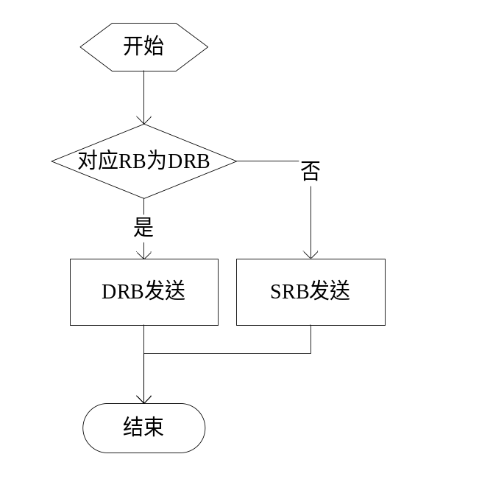
输出
无。
返回
0：成功。
-1：失败

3.5.2测试用例

测试用例：eNB_PDCP_0010

说明 | 测试当发送SRB时，数据发送流程是否正确。
输入 | rb_type为SRB， 有完整性保护
预期输出 | 按照正确的格式打包SRB PDCP PDU：  且SN值递增

测试方法
在测试环境中创建PDCP实体，使被测函数取得此PDCP实体，按照需求配置PDCP实体后，然后构造PDCP SDU，调用发送函数，达到测试目的
测试输出
SRB entity created
RLC received PDU count:0
The memory "PDCP PDU:" len is: 15
0 0 1 2 3 4 5 6 7 8 9 17 39 6d c8
RLC received PDU count:1
The memory "PDCP PDU:" len is: 15
1 1 2 3 4 5 6 7 8 9 a df 56 1e 81
RLC received PDU count:2
The memory "PDCP PDU:" len is: 15
2 2 3 4 5 6 7 8 9 a b 7c eb 44 f8
RLC received PDU count:3
The memory "PDCP PDU:" len is: 15
3 3 4 5 6 7 8 9 a b c 94 ec fd 33
RLC received PDU count:4
The memory "PDCP PDU:" len is: 15
4 4 5 6 7 8 9 a b c d 78 8a 45 13
RLC received PDU count:5
The memory "PDCP PDU:" len is: 15
5 5 6 7 8 9 a b c d e d dc bc fd
RLC received PDU count:6
The memory "PDCP PDU:" len is: 15
6 6 7 8 9 a b c d e f 89 2b 96 b6
RLC received PDU count:7
The memory "PDCP PDU:" len is: 15
7 7 8 9 a b c d e f 10 6c 8c 31 1c
RLC received PDU count:8
The memory "PDCP PDU:" len is: 15
8 8 9 a b c d e f 10 11 94 47 ed 84
RLC received PDU count:9
The memory "PDCP PDU:" len is: 15
9 9 a b c d e f 10 11 12 73 74 8c 80
delete pdcp entity success!
malloc() used 82, free() used 82
All the memory that has been assigned has been released!
There is no mem which has been freed 2 times

测试用例：eNB_PDCP_0011

说明 | 测试当发送DRB时，数据发送流程是否正确
输入 | rbtype 为DRB rlc_mode为AM
预期输出 | 按照正确的格式打包SRB PDCP PDU：  SN值递增

测试方法
在测试环境中创建PDCP实体，使被测函数取得此PDCP实体，按照需求配置PDCP实体后，然后构造PDCP SDU，调用发送函数，达到测试目的。
测试输出
DRB entity created
RLC received PDU count:0
The memory "PDCP PDU:" len is: 12
80 0 0 1 2 3 4 5 6 7 8 9
RLC received PDU count:1
The memory "PDCP PDU:" len is: 12
80 1 1 2 3 4 5 6 7 8 9 a
RLC received PDU count:2
The memory "PDCP PDU:" len is: 12
80 2 2 3 4 5 6 7 8 9 a b
RLC received PDU count:3
The memory "PDCP PDU:" len is: 12
80 3 3 4 5 6 7 8 9 a b c
RLC received PDU count:4
The memory "PDCP PDU:" len is: 12
80 4 4 5 6 7 8 9 a b c d
RLC received PDU count:5
The memory "PDCP PDU:" len is: 12
80 5 5 6 7 8 9 a b c d e
RLC received PDU count:6
The memory "PDCP PDU:" len is: 12
80 6 6 7 8 9 a b c d e f
RLC received PDU count:7
The memory "PDCP PDU:" len is: 12
80 7 7 8 9 a b c d e f 10
RLC received PDU count:8
The memory "PDCP PDU:" len is: 12
80 8 8 9 a b c d e f 10 11
RLC received PDU count:9
The memory "PDCP PDU:" len is: 12
80 9 9 a b c d e f 10 11 12
sdu in sdu buffer:
count:0
The memory "sdu:" len is: 10
0 1 2 3 4 5 6 7 8 9
count:1
The memory "sdu:" len is: 10
1 2 3 4 5 6 7 8 9 a
count:2
The memory "sdu:" len is: 10
2 3 4 5 6 7 8 9 a b
count:3
The memory "sdu:" len is: 10
3 4 5 6 7 8 9 a b c
count:4
The memory "sdu:" len is: 10
4 5 6 7 8 9 a b c d
count:5
The memory "sdu:" len is: 10
5 6 7 8 9 a b c d e
count:6
The memory "sdu:" len is: 10
6 7 8 9 a b c d e f
count:7
The memory "sdu:" len is: 10
7 8 9 a b c d e f 10
count:8
The memory "sdu:" len is: 10
8 9 a b c d e f 10 11
count:9
The memory "sdu:" len is: 10
9 a b c d e f 10 11 12
malloc() used 66, free() used 66
All the memory that has been assigned has been released!
There is no mem which has been freed 2 times

3.6 被测函数：INT32 receive_srb(Rnti ue_rnti, UINT8 rb_id, UINT8 *msg_p, UINT32 len)

3.6.1 函数描述：
功能描述
PDCP SRB接收函数，SRB数据均为AM模式。在解包 解密，完整性验证之后上交给RRC层。
输入
ue_id：用来区分不同UE的标志号。
rb_id：用来区分不同RB的标识号。
msg_p：数据指针，即PDCP PDU。
len：数据长度，字节为单位。
算法与处理流程
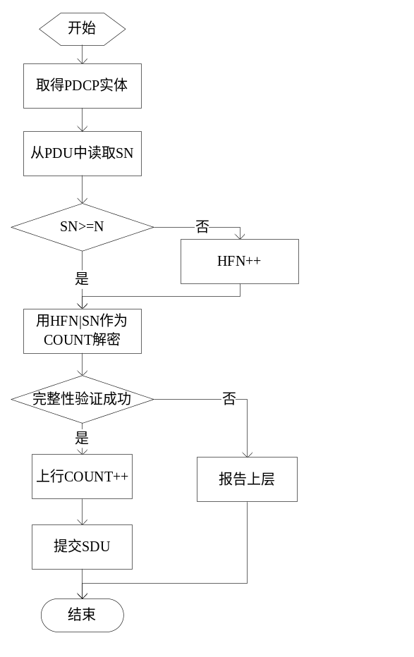
输出
无。
返回
0：成功。
-1：失败

3.6.2测试用例

测试用例：eNB_PDCP_0012

说明 | 测试接收流程，解包及序列号维护。
输入 | SRB实体ul_count初始值为0，接收PDU的序列号序列为：  0，1，2，3，4，10，11，12，13，14，0，1，2，3，4；  PDU中数据部分长度为9，数据为全1  PDU 格式：
预期输出 | ul_count值序列：  0，1，2，3，4，5，11，12，13，14，15，33，34，35，36，37

测试方法
在测试环境中创建相应的PDCP实体，并按照需求配置PDCP实体，构造PDCP PDU，并作为输入调用被测函数，达到测试目的。
测试输出
SRB entity created
ul_count:0
RRC received SDU:
The memory "PDCP SDU:" len is: 9
ff ff ff ff ff ff ff ff ff
ul_count:1
RRC received SDU:
The memory "PDCP SDU:" len is: 9
ff ff ff ff ff ff ff ff ff
ul_count:2
RRC received SDU:
The memory "PDCP SDU:" len is: 9
ff ff ff ff ff ff ff ff ff
ul_count:3
RRC received SDU:
The memory "PDCP SDU:" len is: 9
ff ff ff ff ff ff ff ff ff
ul_count:4
RRC received SDU:
The memory "PDCP SDU:" len is: 9
ff ff ff ff ff ff ff ff ff
ul_count:5
RRC received SDU:
The memory "PDCP SDU:" len is: 9
ff ff ff ff ff ff ff ff ff
ul_count:11
RRC received SDU:
The memory "PDCP SDU:" len is: 9
ff ff ff ff ff ff ff ff ff
ul_count:12
RRC received SDU:
The memory "PDCP SDU:" len is: 9
ff ff ff ff ff ff ff ff ff
ul_count:13
RRC received SDU:
The memory "PDCP SDU:" len is: 9
ff ff ff ff ff ff ff ff ff
ul_count:14
RRC received SDU:
The memory "PDCP SDU:" len is: 9
ff ff ff ff ff ff ff ff ff
ul_count:15
RRC received SDU:
The memory "PDCP SDU:" len is: 9
ff ff ff ff ff ff ff ff ff
ul_count:33
RRC received SDU:
The memory "PDCP SDU:" len is: 9
ff ff ff ff ff ff ff ff ff
ul_count:34
RRC received SDU:
The memory "PDCP SDU:" len is: 9
ff ff ff ff ff ff ff ff ff
ul_count:35
RRC received SDU:
The memory "PDCP SDU:" len is: 9
ff ff ff ff ff ff ff ff ff
ul_count:36
RRC received SDU:
The memory "PDCP SDU:" len is: 9
ff ff ff ff ff ff ff ff ff
ul_count:37
delete pdcp entity success!
malloc() used 46, free() used 46
All the memory that has been assigned has been released!
There is no mem which has been freed 2 times

测试用例：eNB_PDCP_0013

说明 | 测试函数在完整性验证失败后的行为
输入 | PDU格式  其中 DATA和MaC-I 均为全1
预期输出 | 完整性验证失败，通知RRC层

测试方法
在测试环境中创建相应的PDCP实体，并按照需求配置PDCP实体，构造PDCP PDU，并作为输入调用被测函数，达到测试目的。
测试输出
SRB entity created
integrity verified failed...
integrity verified failed...
integrity verified failed...
integrity verified failed...
integrity verified failed...
integrity verified failed...
integrity verified failed...
integrity verified failed...
integrity verified failed...
integrity verified failed...
delete pdcp entity success!
malloc() used 61, free() used 61
All the memory that has been assigned has been released!
There is no mem which has been freed 2 times

3.7 被测函数：INT32 process_status_report (Rnti ue_rnti，UINT8 rb_id ,UINT32 fms_count，UINT8 *bitmap_p, UINT32 bitmap_len)

3.7.1 函数描述：
功能描述
根据对端传过来的状态报告，对本端缓存中的已经被对端确认收到的SDU进行删除，并通知下层取消此PDU的发送。
输入
ue_rnti：UE的RNTI值。
rb_id：无线承载号
fms_count:指示对端缺失的最小COUNT值的PDU
bitmap_p:指示对端缺失的PDU的bitmap，在bitmap中，位置为n（从MSB位开始算）的bit为1表示COUNT = fms_count+ n 的PDU已经被对端收到，为0 表示此PDU未被对端正确收到
bitmap_len：bitmap的长度 以字节为单位。
算法与处理流程
略
输出
无。
返回
0：成功。
-1：失败

3.7.2测试用例

测试用例：eNB_PDCP_0014

说明 | 当SN值较小时，测试函数是否能按照说明删除发送缓存中的SDU
输入 | 发送SDU缓存中的SDU COUNT值：  20，21，22，23，25，26，27，28，29，30，31，32，33，34，35，36，37，38，39  状态报告内容：  fms：23  bitmap：00001111 00000000₂
预期输出 | 状态报告处理完之后 发送SDU缓存中的COUNT值：  23，24，25，26，27，32，33，34，35，36，37，38，39  同时 通知下层取消对应PDU的传送

测试方法
在测试环境中创建PDCP实体，然后按照需求发送若干PDCP SDU，然后构造PDCP status report PDU，并作为输入调用被测函数，达到测试目的。
测试输出
DRB entity created
RLC received PDU count:14
The memory "PDCP PDU:" len is: 12
80 14 0 1 2 3 4 5 6 7 8 9
RLC received PDU count:15
The memory "PDCP PDU:" len is: 12
80 15 1 2 3 4 5 6 7 8 9 a
RLC received PDU count:16
The memory "PDCP PDU:" len is: 12
80 16 2 3 4 5 6 7 8 9 a b
RLC received PDU count:17
The memory "PDCP PDU:" len is: 12
80 17 3 4 5 6 7 8 9 a b c
RLC received PDU count:18
The memory "PDCP PDU:" len is: 12
80 18 4 5 6 7 8 9 a b c d
RLC received PDU count:19
The memory "PDCP PDU:" len is: 12
80 19 5 6 7 8 9 a b c d e
RLC received PDU count:1a
The memory "PDCP PDU:" len is: 12
80 1a 6 7 8 9 a b c d e f
RLC received PDU count:1b
The memory "PDCP PDU:" len is: 12
80 1b 7 8 9 a b c d e f 10
RLC received PDU count:1c
The memory "PDCP PDU:" len is: 12
80 1c 8 9 a b c d e f 10 11
RLC received PDU count:1d
The memory "PDCP PDU:" len is: 12
80 1d 9 a b c d e f 10 11 12
RLC received PDU count:1e
The memory "PDCP PDU:" len is: 12
80 1e a b c d e f 10 11 12 13
RLC received PDU count:1f
The memory "PDCP PDU:" len is: 12
80 1f b c d e f 10 11 12 13 14
RLC received PDU count:20
The memory "PDCP PDU:" len is: 12
80 20 c d e f 10 11 12 13 14 15
RLC received PDU count:21
The memory "PDCP PDU:" len is: 12
80 21 d e f 10 11 12 13 14 15 16
RLC received PDU count:22
The memory "PDCP PDU:" len is: 12
80 22 e f 10 11 12 13 14 15 16 17
RLC received PDU count:23
The memory "PDCP PDU:" len is: 12
80 23 f 10 11 12 13 14 15 16 17 18
RLC received PDU count:24
The memory "PDCP PDU:" len is: 12
80 24 10 11 12 13 14 15 16 17 18 19
RLC received PDU count:25
The memory "PDCP PDU:" len is: 12
80 25 11 12 13 14 15 16 17 18 19 1a
RLC received PDU count:26
The memory "PDCP PDU:" len is: 12
80 26 12 13 14 15 16 17 18 19 1a 1b
RLC received PDU count:27
The memory "PDCP PDU:" len is: 12
80 27 13 14 15 16 17 18 19 1a 1b 1c
count in sdu buffer before:
20 21 22 23 24 25 26 27 28 29 30 31 32 33 34 35 36 37 38 39
The bits of memory bit map is:
00001111 00000000
cancel the transfer of 28 PDU
cancel the transfer of 29 PDU
cancel the transfer of 30 PDU
cancel the transfer of 31 PDU
count in sdu buffer after:
23 24 25 26 27 32 33 34 35 36 37 38 39
malloc() used 127, free() used 127
All the memory that has been assigned has been released!
There is no mem which has been freed 2 times

测试用例：eNB_PDCP_0015

说明 | 当SN值较大时，测试函数是否能按照说明删除发送缓存中的SDU
输入 | 发送SDU缓存中的SDU COUNT值：  0xFFFFFF0F ~ 0xFFFFFF22  状态报告内容：  fms：0xFFFFFF13  bitmap：00001111 00000000₂
预期输出 | 状态报告处理完之后 发送SDU缓存中的COUNT值：  4294967059(0xFFFFFF13), 4294967060(0xFFFFFF14), 4294967061(0xFFFFFF15), 4294967062(0xFFFFFF16), 4294967063(0xFFFFFF17), 4294967068(0xFFFFFF1c),  4294967069(0xFFFFFF1d), 4294967070(0xFFFFFF1e) 4294967071(0xFFFFFF1f), 4294967072(0xFFFFFF20)  4294967073(0xFFFFFF21), 4294967074(0xFFFFFF22)

测试方法
在测试环境中创建PDCP实体，然后按照需求发送若干PDCP SDU，然后构造PDCP status report PDU，并作为输入调用被测函数，达到测试目的。。
测试输出
DRB entity created
RLC received PDU count:ffffff0f
The memory "PDCP PDU:" len is: 12
8f f 0 1 2 3 4 5 6 7 8 9
RLC received PDU count:ffffff10
The memory "PDCP PDU:" len is: 12
8f 10 1 2 3 4 5 6 7 8 9 a
RLC received PDU count:ffffff11
The memory "PDCP PDU:" len is: 12
8f 11 2 3 4 5 6 7 8 9 a b
RLC received PDU count:ffffff12
The memory "PDCP PDU:" len is: 12
8f 12 3 4 5 6 7 8 9 a b c
RLC received PDU count:ffffff13
The memory "PDCP PDU:" len is: 12
8f 13 4 5 6 7 8 9 a b c d
RLC received PDU count:ffffff14
The memory "PDCP PDU:" len is: 12
8f 14 5 6 7 8 9 a b c d e
RLC received PDU count:ffffff15
The memory "PDCP PDU:" len is: 12
8f 15 6 7 8 9 a b c d e f
RLC received PDU count:ffffff16
The memory "PDCP PDU:" len is: 12
8f 16 7 8 9 a b c d e f 10
RLC received PDU count:ffffff17
The memory "PDCP PDU:" len is: 12
8f 17 8 9 a b c d e f 10 11
RLC received PDU count:ffffff18
The memory "PDCP PDU:" len is: 12
8f 18 9 a b c d e f 10 11 12
RLC received PDU count:ffffff19
The memory "PDCP PDU:" len is: 12
8f 19 a b c d e f 10 11 12 13
RLC received PDU count:ffffff1a
The memory "PDCP PDU:" len is: 12
8f 1a b c d e f 10 11 12 13 14
RLC received PDU count:ffffff1b
The memory "PDCP PDU:" len is: 12
8f 1b c d e f 10 11 12 13 14 15
RLC received PDU count:ffffff1c
The memory "PDCP PDU:" len is: 12
8f 1c d e f 10 11 12 13 14 15 16
RLC received PDU count:ffffff1d
The memory "PDCP PDU:" len is: 12
8f 1d e f 10 11 12 13 14 15 16 17
RLC received PDU count:ffffff1e
The memory "PDCP PDU:" len is: 12
8f 1e f 10 11 12 13 14 15 16 17 18
RLC received PDU count:ffffff1f
The memory "PDCP PDU:" len is: 12
8f 1f 10 11 12 13 14 15 16 17 18 19
RLC received PDU count:ffffff20
The memory "PDCP PDU:" len is: 12
8f 20 11 12 13 14 15 16 17 18 19 1a
RLC received PDU count:ffffff21
The memory "PDCP PDU:" len is: 12
8f 21 12 13 14 15 16 17 18 19 1a 1b
RLC received PDU count:ffffff22
The memory "PDCP PDU:" len is: 12
8f 22 13 14 15 16 17 18 19 1a 1b 1c
count in sdu buffer before:
4294967055 4294967056 4294967057 4294967058 4294967059 4294967060 4294967061 4294967062 4294967063 4294967064 4294967065 4294967066 4294967067 4294967068 4294967069 4294967070 4294967071 4294967072 4294967073 4294967074
The bits of memory bit map is:
00001111 00000000
cancel the transfer of 4294967064 PDU
cancel the transfer of 4294967065 PDU
cancel the transfer of 4294967066 PDU
cancel the transfer of 4294967067 PDU
count in sdu buffer after:
4294967059 4294967060 4294967061 4294967062 4294967063 4294967068 4294967069 4294967070 4294967071 4294967072 4294967073 4294967074
malloc() used 127, free() used 127
All the memory that has been assigned has been released!
There is no mem which has been freed 2 times

3.8 被测函数：INT32 receive_drb(Rnti ue_rnti, UINT8 rb_id, UINT8 *msg_p, UINT32 msg_len)

3.8.1 函数描述：
功能描述
PDCP DRB接收函数。 处理PDCP PDU，PDU分为两类，控制PDU和数据PDU。
输入
ue_id：用来区分不同UE的标志号。
rb_id：用来区分不同RB的标识号
msg_p：数据指针，即PDCP PDU。
len：数据长度，字节为单位。
算法与处理流程
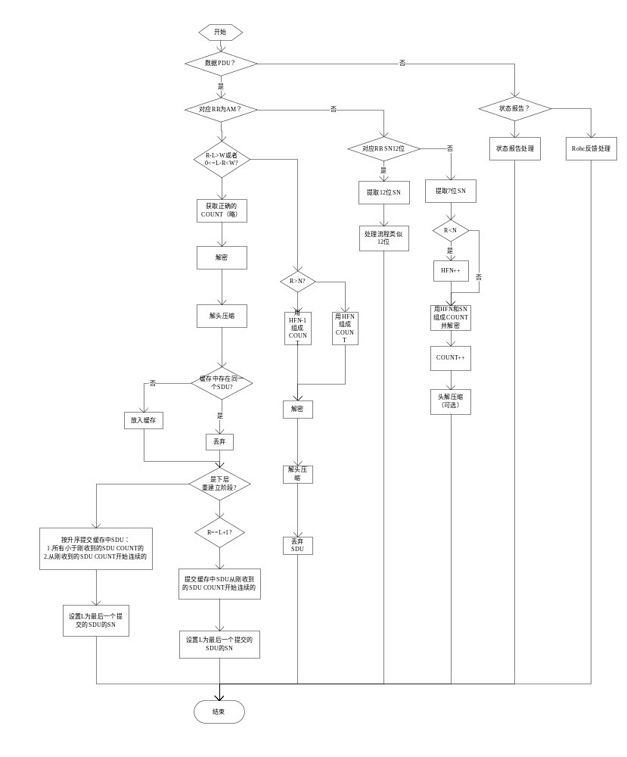
输出
无。
返回
0：成功。
-1：失败

3.8.2测试用例

测试用例：eNB_PDCP_0016

说明 | 测试函数处理状态报告的过程是否正确。
输入 | DRB AM  首先发送20个PDU ，COUNT值分别为：  20，21，22，23，24，25，26，27，28，29，30，31，32，33，34，35，36，37，38，39  PDU格式：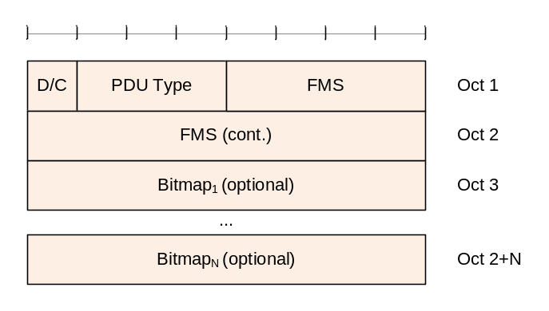  0000 0000  0001 0111  0000 1111  0000 0000
预期输出 | 接收到状态报告后，应对发送缓存中的SDU进行删除，根据状态报告删除SDU之后的缓存链表中节点的COUNT值分别为：  23，24，25，26，27， 32，33，34，35，36，37，38，39

测试方法
在测试环境中创建PDCP实体，然后按照需求发送若干PDCP SDU，然后构造PDCP PDU，并作为输入调用被测函数，达到测试目的。
测试输出
DRB entity created
RLC received PDU count:14
The memory "PDCP PDU:" len is: 12
80 14 0 1 2 3 4 5 6 7 8 9
RLC received PDU count:15
The memory "PDCP PDU:" len is: 12
80 15 1 2 3 4 5 6 7 8 9 a
RLC received PDU count:16
The memory "PDCP PDU:" len is: 12
80 16 2 3 4 5 6 7 8 9 a b
RLC received PDU count:17
The memory "PDCP PDU:" len is: 12
80 17 3 4 5 6 7 8 9 a b c
RLC received PDU count:18
The memory "PDCP PDU:" len is: 12
80 18 4 5 6 7 8 9 a b c d
RLC received PDU count:19
The memory "PDCP PDU:" len is: 12
80 19 5 6 7 8 9 a b c d e
RLC received PDU count:1a
The memory "PDCP PDU:" len is: 12
80 1a 6 7 8 9 a b c d e f
RLC received PDU count:1b
The memory "PDCP PDU:" len is: 12
80 1b 7 8 9 a b c d e f 10
RLC received PDU count:1c
The memory "PDCP PDU:" len is: 12
80 1c 8 9 a b c d e f 10 11
RLC received PDU count:1d
The memory "PDCP PDU:" len is: 12
80 1d 9 a b c d e f 10 11 12
RLC received PDU count:1e
The memory "PDCP PDU:" len is: 12
80 1e a b c d e f 10 11 12 13
RLC received PDU count:1f
The memory "PDCP PDU:" len is: 12
80 1f b c d e f 10 11 12 13 14
RLC received PDU count:20
The memory "PDCP PDU:" len is: 12
80 20 c d e f 10 11 12 13 14 15
RLC received PDU count:21
The memory "PDCP PDU:" len is: 12
80 21 d e f 10 11 12 13 14 15 16
RLC received PDU count:22
The memory "PDCP PDU:" len is: 12
80 22 e f 10 11 12 13 14 15 16 17
RLC received PDU count:23
The memory "PDCP PDU:" len is: 12
80 23 f 10 11 12 13 14 15 16 17 18
RLC received PDU count:24
The memory "PDCP PDU:" len is: 12
80 24 10 11 12 13 14 15 16 17 18 19
RLC received PDU count:25
The memory "PDCP PDU:" len is: 12
80 25 11 12 13 14 15 16 17 18 19 1a
RLC received PDU count:26
The memory "PDCP PDU:" len is: 12
80 26 12 13 14 15 16 17 18 19 1a 1b
RLC received PDU count:27
The memory "PDCP PDU:" len is: 12
80 27 13 14 15 16 17 18 19 1a 1b 1c
count in sdu buffer before:
20 21 22 23 24 25 26 27 28 29 30 31 32 33 34 35 36 37 38 39
The bits of memory pdcp pdu is:
00000000 00010111 00001111 00000000
cancel the transfer of 28 PDU
cancel the transfer of 29 PDU
cancel the transfer of 30 PDU
cancel the transfer of 31 PDU
count in sdu buffer after:
23 24 25 26 27 32 33 34 35 36 37 38 39
malloc() used 127, free() used 127
All the memory that has been assigned has been released!
There is no mem which has been freed 2 times

测试用例：eNB_PDCP_0017

说明 | 测试函数对ROHC 反馈包的处理过程是否正确
输入 | DRB AM  PDU格式：  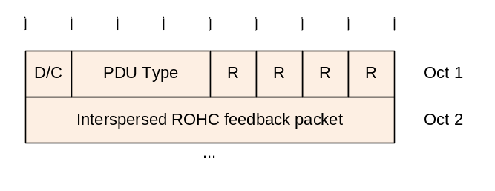  0001 0000  0000 0000
预期输出 | 通过打印消息，显示函数流程正确

测试方法
在测试环境中创建PDCP实体，然后按照需求发送若干PDCP SDU，然后构造PDCP PDU，并作为输入调用被测函数，达到测试目的。
测试输出
DRB entity created
The bits of memory pdcp pdu is:
00010000 00000000
process ctrl pdu rohc feedback
malloc() used 7, free() used 7
All the memory that has been assigned has been released!
There is no mem which has been freed 2 times

测试用例：eNB_PDCP_0018

说明 | 测试函数对DATA PDU（UM）的处理过程（sn_size = 7）
输入 | DRB UM  序列号长度为7 ， NEXT_SN = 127  PDU格式：  依次输入7个PDCP PDU  1111 1100 0000 0000 （SN=124）  1000 0010 0000 0001 （SN = 2）  1000 0010 0000 0010 （SN = 2）  1000 0011 0000 0011 （SN = 3）  1000 0100 0000 0100 （SN = 4）  1000 0101 0000 0101 （SN = 5）  1000 0110 0000 0110 （SN = 6）
预期输出 | 依次接收到各个SDU 本地ul_count值依次为  125 131 259 260 261 262，263

测试方法
在测试环境中创建PDCP实体，然后按照需求发送若干PDCP SDU，然后构造PDCP PDU，并作为输入调用被测函数，达到测试目的。
测试输出
DRB entity created
ul_count: 125
IP received SDU:
The memory "PDCP SDU:" len is: 1
0
ul_count: 131
IP received SDU:
The memory "PDCP SDU:" len is: 1
1
ul_count: 259
IP received SDU:
The memory "PDCP SDU:" len is: 1
2
ul_count: 260
IP received SDU:
The memory "PDCP SDU:" len is: 1
3
ul_count: 261
IP received SDU:
The memory "PDCP SDU:" len is: 1
4
ul_count: 262
IP received SDU:
The memory "PDCP SDU:" len is: 1
5
ul_count: 263
IP received SDU:
The memory "PDCP SDU:" len is: 1
6
malloc() used 27, free() used 27
All the memory that has been assigned has been released!
There is no mem which has been freed 2 times

测试用例：eNB_PDCP_0019

说明 | 测试函数对DATA PDU（UM）的处理过程（sn_size = 12）
输入 | NEXT_SN 初始为 4092（0x0FFC）  PDU格式：  依次输入7个PDU  1000 1111 1111 1100 0000 0000（SN=4092）  1000 0000 0000 0010 0000 0001 （SN=2）  1000 0000 0000 0011 0000 0010 （SN=3）  1000 0000 0000 0100 0000 0011 （SN=4）  1000 0000 0000 0101 0000 0100 （SN=5）  1000 0000 0000 0110 0000 0101 （SN=6）  1000 0000 0000 0111 0000 0110 （SN=7）
预期输出 | IP层依次接收到各个PDU，本地ul_count依次为：  4093 4099 4100 4101 4102 4103 4104

测试方法
在测试环境中创建PDCP实体，然后按照需求发送若干PDCP SDU，然后构造PDCP PDU，并作为输入调用被测函数，达到测试目的。
测试输出
DRB entity created
ul_count: 4093
IP received SDU:
The memory "PDCP SDU:" len is: 1
0
ul_count: 4099
IP received SDU:
The memory "PDCP SDU:" len is: 1
1
ul_count: 4100
IP received SDU:
The memory "PDCP SDU:" len is: 1
2
ul_count: 4101
IP received SDU:
The memory "PDCP SDU:" len is: 1
3
ul_count: 4102
IP received SDU:
The memory "PDCP SDU:" len is: 1
4
ul_count: 4103
IP received SDU:
The memory "PDCP SDU:" len is: 1
5
ul_count: 4104
IP received SDU:
The memory "PDCP SDU:" len is: 1
6
malloc() used 27, free() used 27
All the memory that has been assigned has been released!
There is no mem which has been freed 2 times

测试用例：eNB_PDCP_0020

说明 | 测试函数对DATA PDU（AM） 在RLC_NORMAL状态下的接收过程
输入 | DRB AM  RLC状态为RLC_NORMAL  NEXT_SN = 0x0FFC（4092）  last_submit_sn = 0x0FFB（4091）  PDU格式：  依次发送7个PDU：  1000 1111 1111 1100 0000 0000（SN=4092）  1000 0000 0000 0010 0000 0001 （SN=2）  1000 0000 0000 0011 0000 0010 （SN=3）  1000 0000 0000 0100 0000 0011 （SN=4）  1000 0000 0000 0101 0000 0100 （SN=5）  1000 0000 0000 0110 0000 0101 （SN=6）  1000 0000 0000 0111 0000 0110 （SN=7）
预期输出 | next_sn 和last_submit_sn依次为  4092 4091  4093 4092  3 2  4 3  5 4  6 5  7 6  并且 IP层依次收到各个SDU

测试方法
在测试环境中创建PDCP实体，然后按照需求发送若干PDCP SDU，然后构造PDCP PDU，并作为输入调用被测函数，达到测试目的。
测试输出
DRB entity created

next_sn:4092(ffc),last_submit_sn:4091(ffb),receive sn:4092(ffc) first add or biggest count:4092
the sdu node in the rx list:
4092(ffc)
the current rlc state:normal
IP received SDU:
The memory "PDCP SDU:" len is: 1
0

next_sn:4093(ffd),last_submit_sn:4092(ffc),receive sn:2(2) first add or biggest count:4098
the sdu node in the rx list:
4098(1002)
the current rlc state:normal
IP received SDU:
The memory "PDCP SDU:" len is: 1
1

next_sn:3(3),last_submit_sn:2(2),receive sn:3(3) first add or biggest count:4099
the sdu node in the rx list:
4099(1003)
the current rlc state:normal
IP received SDU:
The memory "PDCP SDU:" len is: 1
2

next_sn:4(4),last_submit_sn:3(3),receive sn:4(4) first add or biggest count:4100
the sdu node in the rx list:
4100(1004)
the current rlc state:normal
IP received SDU:
The memory "PDCP SDU:" len is: 1
3

next_sn:5(5),last_submit_sn:4(4),receive sn:5(5) first add or biggest count:4101
the sdu node in the rx list:
4101(1005)
the current rlc state:normal
IP received SDU:
The memory "PDCP SDU:" len is: 1
4

next_sn:6(6),last_submit_sn:5(5),receive sn:6(6) first add or biggest count:4102
the sdu node in the rx list:
4102(1006)
the current rlc state:normal
IP received SDU:
The memory "PDCP SDU:" len is: 1
5

next_sn:7(7),last_submit_sn:6(6),receive sn:7(7) first add or biggest count:4103
the sdu node in the rx list:
4103(1007)
the current rlc state:normal
IP received SDU:
The memory "PDCP SDU:" len is: 1
6
malloc() used 34, free() used 34
All the memory that has been assigned has been released!
There is no mem which has been freed 2 times

测试用例：eNB_PDCP_0021

说明 | 测试函数在下层重建立过程中的行为是否正确
输入 | DRB AM  RLC层的状态从RLC_NORMAL转到RLC_REESTB  再回到RLC_NORMAL  sn值依次为：4092 ，2，3，4，6，7，5 ，8，9（斜体代表重建立阶段）
预期输出 | PDCP在接收缓存中缓存重建立阶段接收的SDU 重新排序后，再递交到上层

测试方法
在测试环境中创建PDCP实体，然后按照需求发送若干PDCP SDU，然后构造PDCP PDU，并作为输入调用被测函数，达到测试目的。
测试输出
DRB entity created

next_sn:4092(ffc),last_submit_sn:4091(ffb),receive sn:4092(ffc) first add or biggest count:4092
the sdu node in the rx list:
4092(ffc)
the current rlc state:normal
IP received SDU:
The memory "PDCP SDU:" len is: 1
0

next_sn:4093(ffd),last_submit_sn:4092(ffc),receive sn:2(2) first add or biggest count:4098
the sdu node in the rx list:
4098(1002)
the current rlc state:normal
IP received SDU:
The memory "PDCP SDU:" len is: 1
1

next_sn:3(3),last_submit_sn:2(2),receive sn:3(3) first add or biggest count:4099
the sdu node in the rx list:
4099(1003)
the current rlc state:normal
IP received SDU:
The memory "PDCP SDU:" len is: 1
2

next_sn:4(4),last_submit_sn:3(3),receive sn:4(4) first add or biggest count:4100
the sdu node in the rx list:
4100(1004)
the current rlc state:normal
IP received SDU:
The memory "PDCP SDU:" len is: 1
3

next_sn:5(5),last_submit_sn:4(4),receive sn:6(6) first add or biggest count:4102
the sdu node in the rx list:
4102(1006)

next_sn:7(7),last_submit_sn:4(4),receive sn:7(7) first add or biggest count:4103
the sdu node in the rx list:
4102(1006) 4103(1007)

next_sn:8(8),last_submit_sn:4(4),receive sn:5(5) insert count:4101
the sdu node in the rx list:
4101(1005) 4102(1006) 4103(1007)
IP received SDU:
The memory "PDCP SDU:" len is: 1
4
IP received SDU:
The memory "PDCP SDU:" len is: 1
5
IP received SDU:
The memory "PDCP SDU:" len is: 1
6

next_sn:8(8),last_submit_sn:7(7),receive sn:8(8) first add or biggest count:4104
the sdu node in the rx list:
4104(1008)
the current rlc state:normal
IP received SDU:
The memory "PDCP SDU:" len is: 1
7

next_sn:9(9),last_submit_sn:8(8),receive sn:9(9) first add or biggest count:4105
the sdu node in the rx list:
4105(1009)
the current rlc state:normal
IP received SDU:
The memory "PDCP SDU:" len is: 1
8
malloc() used 42, free() used 42
All the memory that has been assigned has been released!
There is no mem which has been freed 2 times

3.9 被测函数：UINT8 create_status_report (UINT32 ls_count，RxPdcpSduList *rx_list_p，UINT32 *pdu_len)

3.9.1 函数描述：
功能描述
在PDCP重建立时，如果对应RB需要发送状态报告，则使用此函数，根据接收缓存链表创建状态报告。
状态报告格式：
FMS代表first missing sn ，即第一个缺失的SDU的SN，bitmap来表示缓存中哪些SDU已经收到，哪些还没有收到。
输入
ls_count：last_submit_sn 上次提交的SDU的SN，即最后提交的SDU的SN，要根据此值来推断FMS。
rx_list_p：接收缓存链表指针。
pdu_len：指示创建好的状态报告PDU的长度。
算法与处理流程
略
输出
无。
返回
成功：状态报告PDU指针
失败：NULL

3.9.2测试用例

测试用例：eNB_PDCP_0022

说明 | 测试生成的状态报告是否正确。
输入 | 接收缓存链表中的COUNT值依次为：  10，14。  last_submit_sn为9
预期输出 | FMS为11  PDU为  0000 0000  0000 1011  0011 1111

测试方法
在测试环境中首先根据需求，构造接收缓存链表，然后调用被测函数生成状态报告，查看状态报告，达到测试目的
测试输出
The bits of memory status report is:
00000000 00001011 00111111

测试用例：eNB_PDCP_0023

说明 | 测试生成的状态报告是否正确。
输入 | 接收缓存链表中的COUNT值依次为：  10 ，11，12，13，14，16，18，20，21。  last_submit_sn为9
预期输出 | FMS为15  PDU为：  0000 0000  0000 1111  1010 1111

测试方法
在测试环境中首先根据需求，构造接收缓存链表，然后调用被测函数生成状态报告，查看状态报告，达到测试目的
测试输出
The bits of memory status report is:
00000000 00001111 10101111

测试用例：eNB_PDCP_0024

说明 | 测试生成的状态报告是否正确。
输入 | 接收缓存链表为空。  last_submit_sn为9
预期输出 | FMS为10  bitmap不存在

测试方法
在测试环境中首先根据需求，构造接收缓存链表，然后调用被测函数生成状态报告，查看状态报告，达到测试目的
测试输出
The bits of memory status report is:
00000000 00001010

3.10 被测函数：INT32 reestablish_pdcp (Rnti ue_rnti,UINT8 rb_id,PdcpConfig pdcp_config_p)

3.10.1 函数描述：
功能描述
根据配置参数和要求，重建立一个PDCP实体。下述情形时，会发生PDCP重建立：
- 切换时，即RRC收到带有mobilityControlInfo的RRCConnectionReconfiguration消息时，此时重建立所有的PDCP实体，包括SRB和DRB。
- RRC连接重建立时，比如切换失败，此时RRC会启动连接重建立，此时需要重建立SRB1对应的PDCP实体。
- RRC收到不带mobilityControlInfo的RRCConnectionReconfiguration消息，但此过程是用来在重建立之后恢复各个RB的，此时需要重建立除SRB1之外所有其他的RB对应的PDCP实体
对于独立出去的安全模块，RRC要保证在PDCP重建立过程中，安全模块与数据传输模块保持同步，确定在重传AM数据之前，对安全参数进行重配置。
输入
ue_id：用来区分不同UE的id号。
rb_id：无线承载ID号
pdcp_config_p：对于DRB的重建立，总是对应着新的配置 对于SRB， 此参数无效。
算法与处理流程
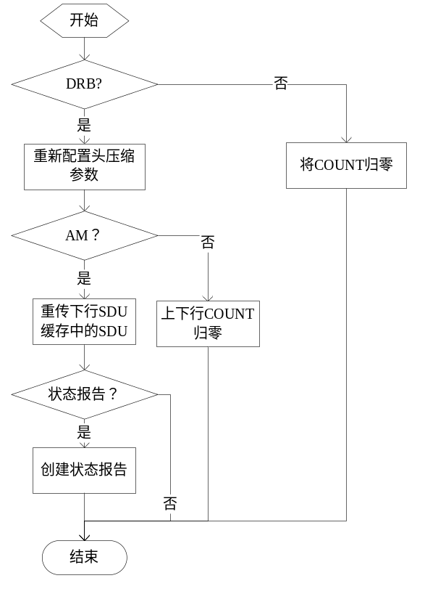
输出
无。
返回
0：成功。
-1：失败

3.10.2测试用例

测试用例：eNB_PDCP_0025

说明 | 测试重建立SRB的过程。
输入 | rb_type = SRB 依次发送10个SDU，接收5个PDU，然后重建立
预期输出 | 重建立前PDCP实体内保存的count值被归零

测试方法
在测试环境中创建PDCP实体，然后构建重建立时需要的新的参数，并将其作为输入调用被测函数，之后检验PDCP实体，达到测试目的。
测试输出
SRB entity created
RLC received PDU count:0
The memory "PDCP PDU:" len is: 11
0 0 1 2 3 4 5 6 7 8 9
RLC received PDU count:1
The memory "PDCP PDU:" len is: 11
1 1 2 3 4 5 6 7 8 9 a
RLC received PDU count:2
The memory "PDCP PDU:" len is: 11
2 2 3 4 5 6 7 8 9 a b
RLC received PDU count:3
The memory "PDCP PDU:" len is: 11
3 3 4 5 6 7 8 9 a b c
RLC received PDU count:4
The memory "PDCP PDU:" len is: 11
4 4 5 6 7 8 9 a b c d
RLC received PDU count:5
The memory "PDCP PDU:" len is: 11
5 5 6 7 8 9 a b c d e
RLC received PDU count:6
The memory "PDCP PDU:" len is: 11
6 6 7 8 9 a b c d e f
RLC received PDU count:7
The memory "PDCP PDU:" len is: 11
7 7 8 9 a b c d e f 10
RLC received PDU count:8
The memory "PDCP PDU:" len is: 11
8 8 9 a b c d e f 10 11
RLC received PDU count:9
The memory "PDCP PDU:" len is: 11
9 9 a b c d e f 10 11 12
ul_count:0
RRC received SDU:
The memory "PDCP SDU:" len is: 9
ff ff ff ff ff ff ff ff ff
ul_count:1
RRC received SDU:
The memory "PDCP SDU:" len is: 9
ff ff ff ff ff ff ff ff ff
ul_count:2
RRC received SDU:
The memory "PDCP SDU:" len is: 9
ff ff ff ff ff ff ff ff ff
ul_count:3
RRC received SDU:
The memory "PDCP SDU:" len is: 9
ff ff ff ff ff ff ff ff ff
ul_count:4
RRC received SDU:
The memory "PDCP SDU:" len is: 9
ff ff ff ff ff ff ff ff ff
ul_count:5
dl_count:10
after reestablishment:
ul_count:0
dl_count:0
delete pdcp entity success!
malloc() used 56, free() used 56
All the memory that has been assigned has been released!

测试用例：eNB_PDCP_0026

说明 | 测试重建立DRB UM模式的过程
输入 | rb_type = DRB rlc_mode=UM_MODE  sn_size=SN_SIZE_12（1）  rohc_flag =FALSE  依次发送10个SDU  然后使用新的配置参数进行重建立  sn_size=SN_SIZE_7（0）  rohc_flag = TRUE
预期输出 | 重建立后 应用新的配置参数

测试方法
在测试环境中创建PDCP实体，然后构建重建立时需要的新的参数，并将其作为输入调用被测函数，之后检验PDCP实体，达到测试目的。
测试输出
DRB entity created
RLC received PDU count:0
The memory "PDCP PDU:" len is: 12
80 0 0 1 2 3 4 5 6 7 8 9
RLC received PDU count:1
The memory "PDCP PDU:" len is: 12
80 1 1 2 3 4 5 6 7 8 9 a
RLC received PDU count:2
The memory "PDCP PDU:" len is: 12
80 2 2 3 4 5 6 7 8 9 a b
RLC received PDU count:3
The memory "PDCP PDU:" len is: 12
80 3 3 4 5 6 7 8 9 a b c
RLC received PDU count:4
The memory "PDCP PDU:" len is: 12
80 4 4 5 6 7 8 9 a b c d
RLC received PDU count:5
The memory "PDCP PDU:" len is: 12
80 5 5 6 7 8 9 a b c d e
RLC received PDU count:6
The memory "PDCP PDU:" len is: 12
80 6 6 7 8 9 a b c d e f
RLC received PDU count:7
The memory "PDCP PDU:" len is: 12
80 7 7 8 9 a b c d e f 10
RLC received PDU count:8
The memory "PDCP PDU:" len is: 12
80 8 8 9 a b c d e f 10 11
RLC received PDU count:9
The memory "PDCP PDU:" len is: 12
80 9 9 a b c d e f 10 11 12
ul_count:0
dl_count:10
sn_size:1
header_comp_p->rohc_flag:0
after reestablishment:
ul_count:0
dl_count:0
sn_size:0
header_comp_p->rohc_flag:1
delete pdcp entity success!
malloc() used 59, free() used 59
All the memory that has been assigned has been released!

测试用例：eNB_PDCP_0027

说明 | 测试重建立DRB AM模式的过程
输入 | 首先发送5个SDU ，COUNT值分别为0~4  rlc_state = RLC_REESTB  接收6个PDU ，COUNT值分别为0，3，4，5，6，7  然后重建立，发送状态报告
预期输出 | 重建立过程中，首先重传缓存中的SDU，然后构造状态报告并发送下去  状态报告PDU：  0000 0000  0000 0001  0111 1111

测试方法
在测试环境中创建PDCP实体，然后构建重建立时需要的新的参数，并将其作为输入调用被测函数，之后检验PDCP实体，达到测试目的。
测试输出
DRB entity created

pdcp sdu sending ....................
RLC received PDU count:0
The memory "PDCP PDU:" len is: 12
80 0 0 1 2 3 4 5 6 7 8 9
RLC received PDU count:1
The memory "PDCP PDU:" len is: 12
80 1 1 2 3 4 5 6 7 8 9 a
RLC received PDU count:2
The memory "PDCP PDU:" len is: 12
80 2 2 3 4 5 6 7 8 9 a b
RLC received PDU count:3
The memory "PDCP PDU:" len is: 12
80 3 3 4 5 6 7 8 9 a b c
RLC received PDU count:4
The memory "PDCP PDU:" len is: 12
80 4 4 5 6 7 8 9 a b c d

sdu in sdu buffer:
count:0
The memory "sdu:" len is: 10
0 1 2 3 4 5 6 7 8 9
count:1
The memory "sdu:" len is: 10
1 2 3 4 5 6 7 8 9 a
count:2
The memory "sdu:" len is: 10
2 3 4 5 6 7 8 9 a b
count:3
The memory "sdu:" len is: 10
3 4 5 6 7 8 9 a b c
count:4
The memory "sdu:" len is: 10
4 5 6 7 8 9 a b c d

pdcp pdu receiving......................

next_sn:0(0),last_submit_sn:4095(fff),receive sn:0(0) first add or biggest count:0
the sdu node in the rx list:
0(0)
IP received SDU:
The memory "PDCP SDU:" len is: 1
1

next_sn:1(1),last_submit_sn:0(0),receive sn:3(3) first add or biggest count:3
the sdu node in the rx list:
3(3)

next_sn:4(4),last_submit_sn:0(0),receive sn:4(4) first add or biggest count:4
the sdu node in the rx list:
3(3) 4(4)

next_sn:5(5),last_submit_sn:0(0),receive sn:5(5) first add or biggest count:5
the sdu node in the rx list:
3(3) 4(4) 5(5)

next_sn:6(6),last_submit_sn:0(0),receive sn:6(6) first add or biggest count:6
the sdu node in the rx list:
3(3) 4(4) 5(5) 6(6)

next_sn:7(7),last_submit_sn:0(0),receive sn:7(7) first add or biggest count:7
the sdu node in the rx list:
3(3) 4(4) 5(5) 6(6) 7(7)

reestablishing......................
RLC received PDU count:0
The memory "PDCP PDU:" len is: 12
80 0 0 1 2 3 4 5 6 7 8 9
RLC received PDU count:1
The memory "PDCP PDU:" len is: 12
40 1 1 2 3 4 5 6 7 8 9 a
RLC received PDU count:2
The memory "PDCP PDU:" len is: 12
d8 2 2 3 4 5 6 7 8 9 a b
RLC received PDU count:3
The memory "PDCP PDU:" len is: 12
a0 3 3 4 5 6 7 8 9 a b c
RLC received PDU count:4
The memory "PDCP PDU:" len is: 12
20 4 4 5 6 7 8 9 a b c d
last submit count:0
RLC received PDU count:0
The memory "PDCP PDU:" len is: 3
0 1 7f
malloc() used 77, free() used 77
All the memory that has been assigned has been released!

3.11 被测函数：INT32 ack4pdcp_sdu (Rnti ue_rnti, UINT8 rb_id, UINT32 count)

3.11.1 函数描述：
功能描述
在RLC收到接收端确认后，指示PDCP删除指定COUNT值的缓存SDU。
输入
ue_id：用来区分不同UE的标志号。
rb_id：用来区分不同RB的标识号。
count：SDU的count值。
算法与处理流程
略
输出
无。
返回
0：成功。
-1：失败

3.11.2测试用例

测试用例：eNB_PDCP_0028

说明 | 测试函数在删除UM对应的SDU时，是否正确。
输入 | UM  依次发送10个PDU COUNT值为0~9  下层依次确认0~4
预期输出 | PDCP层发送缓存中COUNT值为0~4的对应的SDU被删除

测试方法
在测试环境中构造发送缓存链表，然后调用被测函数，通过比较缓存链表前后COUNT值的变化，达到测试目的
测试输出
DRB entity created
RLC received PDU count:0
The memory "PDCP PDU:" len is: 12
80 0 0 1 2 3 4 5 6 7 8 9
RLC received PDU count:1
The memory "PDCP PDU:" len is: 12
80 1 1 2 3 4 5 6 7 8 9 a
RLC received PDU count:2
The memory "PDCP PDU:" len is: 12
80 2 2 3 4 5 6 7 8 9 a b
RLC received PDU count:3
The memory "PDCP PDU:" len is: 12
80 3 3 4 5 6 7 8 9 a b c
RLC received PDU count:4
The memory "PDCP PDU:" len is: 12
80 4 4 5 6 7 8 9 a b c d
RLC received PDU count:5
The memory "PDCP PDU:" len is: 12
80 5 5 6 7 8 9 a b c d e
RLC received PDU count:6
The memory "PDCP PDU:" len is: 12
80 6 6 7 8 9 a b c d e f
RLC received PDU count:7
The memory "PDCP PDU:" len is: 12
80 7 7 8 9 a b c d e f 10
RLC received PDU count:8
The memory "PDCP PDU:" len is: 12
80 8 8 9 a b c d e f 10 11
RLC received PDU count:9
The memory "PDCP PDU:" len is: 12
80 9 9 a b c d e f 10 11 12
sdu in sdu buffer:
count:0
no sdu buffer
count:1
no sdu buffer
count:2
no sdu buffer
count:3
no sdu buffer
count:4
no sdu buffer
count:5
no sdu buffer
count:6
no sdu buffer
count:7
no sdu buffer
count:8
no sdu buffer
count:9
no sdu buffer
ack comes ......

sdu in sdu buffer:
count:5
no sdu buffer
count:6
no sdu buffer
count:7
no sdu buffer
count:8
no sdu buffer
count:9
no sdu buffer
malloc() used 56, free() used 56
All the memory that has been assigned has been released!
There is no mem which has been freed 2 times

测试用例：eNB_PDCP_0029

说明 | 测试函数在删除AM对应的SDU时，是否正确
输入 | AM  依次发送10个PDU COUNT值为0~9  下层依次确认3，4，5
预期输出 | PDCP层发送缓存中COUNT值为3,4,5的对应的SDU被删除

测试方法
在测试环境中构造发送缓存链表，然后调用被测函数，通过比较缓存链表前后COUNT值的变化，达到测试目的。
测试输出
DRB entity created
RLC received PDU count:0
The memory "PDCP PDU:" len is: 12
80 0 0 1 2 3 4 5 6 7 8 9
RLC received PDU count:1
The memory "PDCP PDU:" len is: 12
80 1 1 2 3 4 5 6 7 8 9 a
RLC received PDU count:2
The memory "PDCP PDU:" len is: 12
80 2 2 3 4 5 6 7 8 9 a b
RLC received PDU count:3
The memory "PDCP PDU:" len is: 12
80 3 3 4 5 6 7 8 9 a b c
RLC received PDU count:4
The memory "PDCP PDU:" len is: 12
80 4 4 5 6 7 8 9 a b c d
RLC received PDU count:5
The memory "PDCP PDU:" len is: 12
80 5 5 6 7 8 9 a b c d e
RLC received PDU count:6
The memory "PDCP PDU:" len is: 12
80 6 6 7 8 9 a b c d e f
RLC received PDU count:7
The memory "PDCP PDU:" len is: 12
80 7 7 8 9 a b c d e f 10
RLC received PDU count:8
The memory "PDCP PDU:" len is: 12
80 8 8 9 a b c d e f 10 11
RLC received PDU count:9
The memory "PDCP PDU:" len is: 12
80 9 9 a b c d e f 10 11 12
sdu in sdu buffer:
count:0
The memory "sdu:" len is: 10
0 1 2 3 4 5 6 7 8 9
count:1
The memory "sdu:" len is: 10
1 2 3 4 5 6 7 8 9 a
count:2
The memory "sdu:" len is: 10
2 3 4 5 6 7 8 9 a b
count:3
The memory "sdu:" len is: 10
3 4 5 6 7 8 9 a b c
count:4
The memory "sdu:" len is: 10
4 5 6 7 8 9 a b c d
count:5
The memory "sdu:" len is: 10
5 6 7 8 9 a b c d e
count:6
The memory "sdu:" len is: 10
6 7 8 9 a b c d e f
count:7
The memory "sdu:" len is: 10
7 8 9 a b c d e f 10
count:8
The memory "sdu:" len is: 10
8 9 a b c d e f 10 11
count:9
The memory "sdu:" len is: 10
9 a b c d e f 10 11 12
ack comes........

sdu in sdu buffer:
count:0
The memory "sdu:" len is: 10
0 1 2 3 4 5 6 7 8 9
count:1
The memory "sdu:" len is: 10
1 2 3 4 5 6 7 8 9 a
count:2
The memory "sdu:" len is: 10
2 3 4 5 6 7 8 9 a b
count:6
The memory "sdu:" len is: 10
6 7 8 9 a b c d e f
count:7
The memory "sdu:" len is: 10
7 8 9 a b c d e f 10
count:8
The memory "sdu:" len is: 10
8 9 a b c d e f 10 11
count:9
The memory "sdu:" len is: 10
9 a b c d e f 10 11 12
malloc() used 66, free() used 66
All the memory that has been assigned has been released!
There is no mem which has been freed 2 times

5 其他测试

